SUBCOURSE EDITION
IT0349 A

US ARMY INTELLIGENCE CENTER

MAGNETISM-ELECTROMAGNETISM

MAGNETISM AND ELECTROMAGNETISM

Subcourse Number IT0349

EDITION A

US ARMY INTELLIGENCE CENTER
FORT HUACHUCA, AZ 85613-6000

3 Credit Hours

Edition Date: December 1996

SUBCOURSE OVERVIEW

This subcourse is designed to teach you the concepts of troubleshooting electronic equipment.

This subcourse replaces SA0733.

There are no prerequisites for this subcourse.

TERMINAL LEARNING OBJECTIVE:

TASK: You will be able to identify correct definitions of and statements about the properties of magnetism, electromagnetism, flux, permeability, reluctance, saturation, retentivity, polarity, lines of forces, and coils, and you will be able to apply the left hand rule.

CONDITION: You will use the information in this subcourse.

STANDARD: To demonstrate your competency of this task, you must achieve a minimum of 70% on the subcourse examination.

i IT0349

TABLE OF CONTENTS

Section Page

Subcourse Overview i

Administrative Instructions iii

Grading and Certification Instructions iii

Lesson 1: Magnetism 1-1

Lesson 2: Electromagnetism 2-1

Examination E-1

Student Inquiry Sheets

IT0349 ii

LESSON 1

MAGNETISM

OVERVIEW

LESSON DESCRIPTION:

In this lesson, you will learn the properties, characteristics, and terms associated with magnetism and magnetic materials.

TERMINAL LEARNING OBJECTIVE:

ACTION: Identify the definition, description, and effects of the properties and characteristics of magnetism.

CONDITION: Given the information provided in this subcourse.

STANDARD: To demonstrate competency of this task, you must achieve a minimum of 70% on the subcourse examination.

INTRODUCTION

The study of magnetism is very simple. Man has learned to apply the laws of nature to achieve certain desired effects. The first effect is navigation by using a compass, and it is used in many electronic devices. Tape recorders, disc drives, aerial navigation, and many more. If you can understand the basics, you can troubleshoot and analyze problems involving magnetism.

1-1 IT0349

1. In ancient times, the Greeks discovered a stone near the town of Magnesia that would attract pieces of iron. The same stone, when suspended by a string, would always swing around to a north-south direction. The stone, which became known by two names (magnetite and lodestone), was the first magnet. From that time, the development of magnets has continued. Today, because they produce a magnetic field, magnets are the most widely used means of generating electricity.

A substance that has the power to attract certain metallic materials such as iron, steel, nickel, and cobalt is said to have the property of magnetism and is called a .

magnet 2. All magnets, whether they are natural, such as the stone called magnetite, or are manmade (artificial), have at least two poles. These poles are called the north pole and the south pole. These poles received their names from the early stones which were used as compasses. The end of the stone which pointed towards the geographic North on the earth was called the north pole. These names stayed in use through the years.

NOTE: The are special manmade magnets that do not have poles, they are closed loop magnets. These are special purpose magnets and we only need to know they exist Their properties and functions are beyond the scope of this lesson.

All magnets have two poles, a pole and a pole.

north 3. Each molecule in a magnet (or in an unmagnetized
south magnetic material) is considered to be a tiny magnet
(either order) in itself. In a magnet most of the molecules are lined up so that their north poles all point in the same
direction. In an unmagnetized bar, the molecules are
arranged at random so that there is no external
magnetic field felt.

Which of the bars shown below would be a magnet A/B
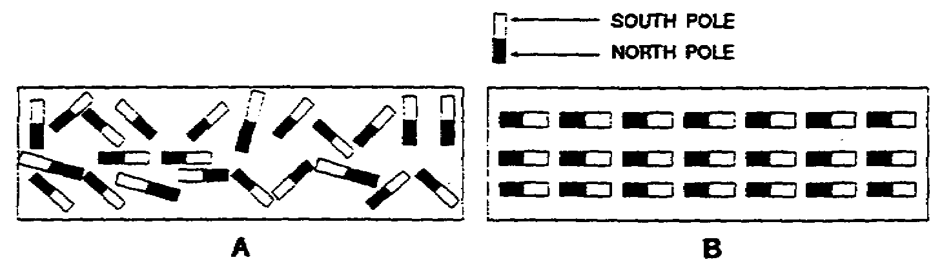

IT0349 1-2

B 4. Label the statements below as true or false.

All magnets have at least two poles.

A substance which has the power to attract all material is called a magnet.

The molecules in a magnet are lined up with their poles all pointing the same direction.

true 5. All magnets are surrounded by a force field, which is
false called the magnetic flux field. This magnetic
true field exists as lines of force which form a closed
loop through and around the magnet. These lines of
force (magnetic field) are called the FLUX FIELD.
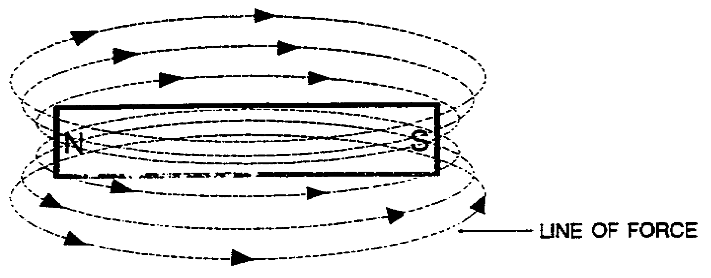

In the above figure, the lines of force are shown with arrows. These lines of force are said to have direction. They extend from the north pole to the south pole, through the magnet, and back to the north pole.

The magnetic field (lines of force) surrounding a magnet is called the .

1-3 IT0349

flux field 6. The lines force around a magnet are said to have the characteristics of a rubber band, that is, they stretch. As they leave and enter the poles, they are concentrated in a small area and have their greatest attraction at these points. As they form around the magnet, they stretch out or become thin as a rubber band will when stretched. In this area, there is very little attraction. The ease with which the lines of force travel through the magnet itself depends on the permeability of the magnetic material.

The area where the lines of force are concentrated or have their greatest attraction is at the .

The ease passage flux (lines of force) through a magnetic material called .

poles 7. The PERMEABILITY is the ease of passage of flux lines
permeability and conversely the opposition to the passage of flux
lines called RELUCTANCE.

The ease of passage of flux lines called .

The opposition to the passage flux lines is called
.

permeability 8. A magnet or magnetic is limited as to how strong it can
reluctance become. The magnetic field can become only so strong
before it reaches its limit. This limit is called
SATURATION. Just as a water pipe is restricted to the
amount of water it can pass, a magnetic substance is
restricted to the number of lines of force it can
contain.

The limit of magnetic strength is called .

IT0349 1-4

saturation 9. We have been studying some of the terms which are used concerning magnetism. The magnetic field (lines of force) is the flux field. The ease of the passage of flux is permeability, while the opposition to the passage flux is reluctance. The limit of the magnetic strength is saturation. In addition to these terms, there a two others which we must learn. The remaining two are concerned with the length of time a magnetic field exists in and around a magnet. RETENTIVITY is the property of a substance to retain magnetism after magnetization has stopped. In other words, if we magnetized a piece of soft iron, in which the molecules rearrange themselves easily; after magnetization was stopped, the iron would quickly lose its magnetism (low retentivity). On the other hand, if we magnetized a piece of hard steel, it would remain a magnet for a considerable length of time (high retentivity).

The property of retaining magnetism after magnetization has stopped is called .

rententivity 10. If we took our piece of hard steel and magnetized it, the amount of magnetism remaining would be called RESIDUAL magnetism.

We can say, then, that the property of retaining magnetism is called while the amount of magnetism remaining is magnetism.

1-5 IT0349

retentivity 11. Match the following statements with term they best describe:

residual Permeability 1. Limit the magnetic strength

Reluctance 2. The ease of passage of flux

Saturation 3. Opposition to the passage of flux

Retentivity 4. The property of retaining magnetism

Flux field 5. The amount of magnetism remaining after magnetization
has stopped

Residual 6. Magnetic field or lines of force

7. The number of lines of force necessary to magnetize

2 12. All the properties and terms that we have been reading
3 about are necessary to know in order to understand
1 magnetism. When you combine all the effects of these
4 properties together, they are best known by the name
6 MAGNETIC FIELD.
5
In electricity, this magnetic field is our primary concern, as this is the major work force which will produce our desired results.

In a nutshell, the area surrounding a magnet which contains lines of force or a flux field is called the
.

magnetic 13. The lines of force or flux field surrounding a magnet
field are called the .

magnetic 14. Write the definition of a magnetic field.
field

IT0349 1-6

The area around a 15. The LAW OF ATTRACTION AND REPULSION is very important,
magnet containing as almost rotating electrical equipment depends upon
a flux field or lines the principle of this law. The law itself is very
of force. simple; it states that like poles repel and unlike
poles attract.

The law of attraction and repulsion states that
poles attract and poles repel.

unlike 16. Write the law of attraction and repulsion.
like

Like poles 17. All the rules, laws, and terms we have used apply to
repel, unlike poles all types of magnets. Magnets are divided into three
attract. general types. The first is the natural magnets.
These are the stones which were discovered long ago in
Greece, and are also found all over the world. Do you
remember two names for natural magnets? They are
and .

1-7 IT0349

magnetite 18. The natural magnets have little practical value, as
lodestone their magnetic field is relatively weak. The
(either order) second type of magnet is the artificial (manmade)
magnet. There are two methods of making an artificial
magnet. One is by the induction method. This is done
by stroking an unmagnetized metal bar repeatedly in the
same direction with a magnet. This will cause the
molecules in the metal bar to line up with their poles
all in the same direction.
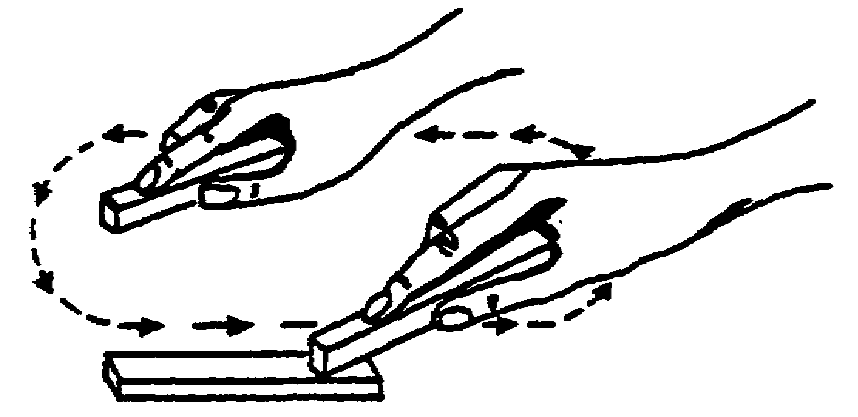

In the figure above, by stroking the metal bar with a magnet, the molecules all line up in the same direction. This produces an magnet by .
(type) (method)

artificial 19. The second method of making an artificial magnet is by
induction the coil method. By wrapping a piece of wire around a
metal bar and passing a DC current through the wire, it
will cause the bar to become magnetized. This method
can be used to produce a very powerful artificial
magnet.
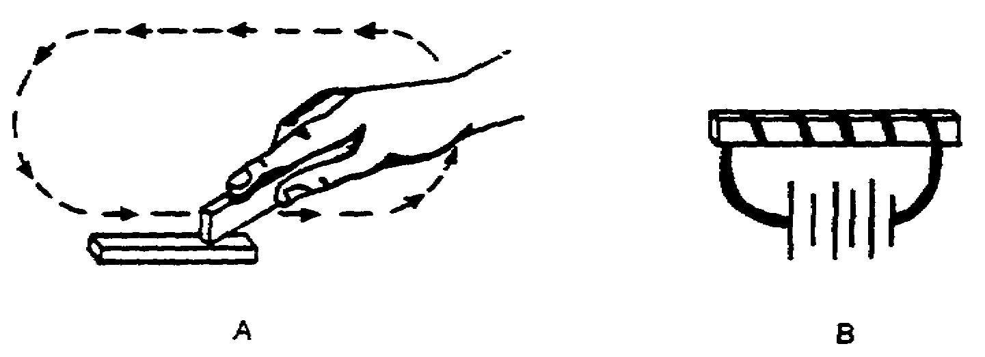

In the above diagrams, we are making artificial magnets by two methods. Figure A is by method; figure B is by method.

IT0349 1-8

induction 20. Artificial magnets are further divided into two
coil classes, temporary and permanent. TEMPORARY magnets
are those which hold their magnetism only a short time.
They are usually made of soft iron. PERMANENT magnet
are those which hold their magnetism for long periods
of time. They are usually made of hard steel or
alnico.

The two classes of artificial magnets are and
.

temporary 21. Our third type of magnet and the most powerful, is the
permanent ELECTROMAGNET. This type of magnet is normally made
with a coil of wire and a core made of soft iron. A DC
current is passed through the coil, inducing a magnetic
field in the iron core. While the current is flowing,
the magnetic strength of the core can be made very
powerful. There are electromagnets which are capable
of picking up whole railroad cars. (The field set up
by the coil will be fully covered later in this
lesson.)

A magnet made with a coil of wire and an iron core is called an .

electromagnet 22. Match the following statements to the magnet they best describe:

Made by induction or coil 1. Natural magnet

Lodestone or magnetite 2. Artificial magnet

Coil of wire with iron core 3. Electromagnet

Has little commercial value
because of weakness of field

1-9 IT0349

Answer to Frame 22

Match the following statements to the magnet they best describe:

2. Made by induction or coil 1. Natural magnet

1. Lodestone or magnetite 2. Artificial magnet

3. Coil of wire with iron core 3. Electromagnet

1. Has little commercial value
because of weakness of field

(END OF LESSON ONE)

IT0349 1-10

LESSON 2

ELECTROMAGNETISM

OVERVIEW

LESSON DESCRIPTION:

In this lesson, you will learn the properties, characteristics, rules, and factors concerning electromagnetism.

TERMINAL LEARNING OBJECTIVE:

ACTION: Identify the correct statement or illustration concerning the properties characteristics, rules and factors describing electromagnetism.

CONDITION: Given the information provides in this subcourse.

STANDARD: To demonstrate competency of this task, you must achieve a minimum of 70% on the subcourse examination.

INTRODUCTION

The theory of electromagnetism is simple to understand, and as is its application in the generation of electricity. In the electronic circuits of electronic equipment electromagnetism doesn't always work according to theory. This lesson only covers the basic elements of the theory, and it will be your challenge to apply the theory in your daily duties.

2-1 IT0349

1. When an electric current flows through a conductor magnetic lines of force are generated at right angles to the conductor. These lines of force, known as flux lines, are formed much as ripples form around a rock dropped into water. The effect of these lines of force is shown in the illustration below.

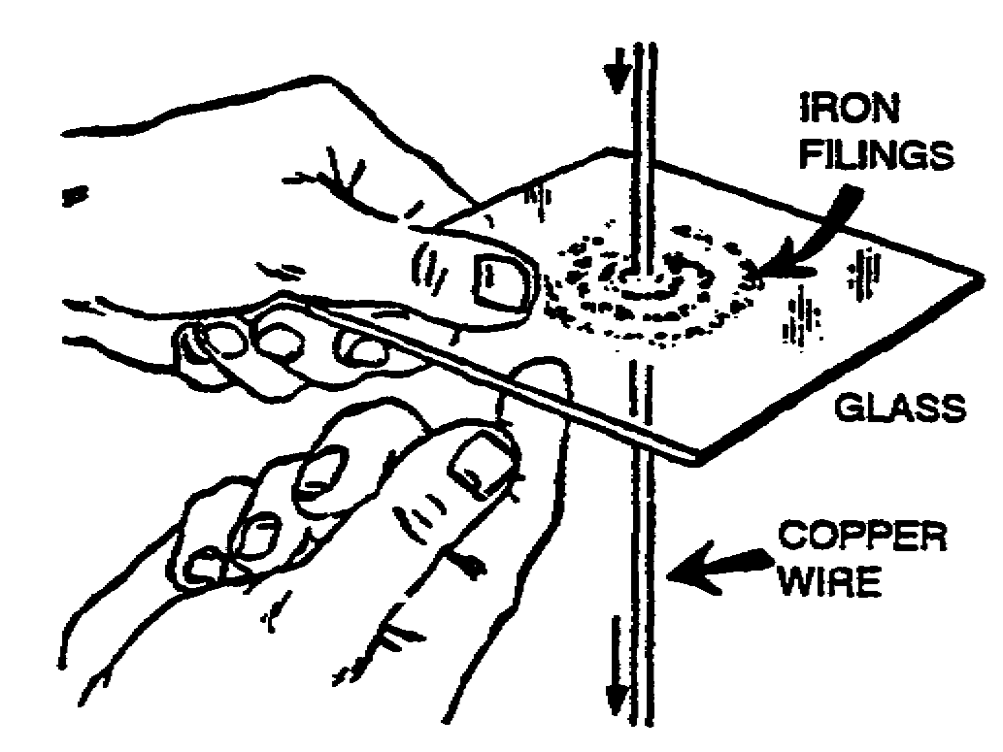

Metal filings sprinkled in the vicinity of the conductor are formed into circles, or rings, by the lines of flux. This field exists only as long as current flows through the conductor. When the current ceases to flow, the field collapses. Although lines of force have no north or south pole, they are directional. Their direction is determined by the direction of current flow through the conductor. To determine the direction of the lines of flux around a conductor, the technician applies the left-hand rule for straight conductors. This rule is illustrated on the following page.

IT0349 2-2

1. (Continued)

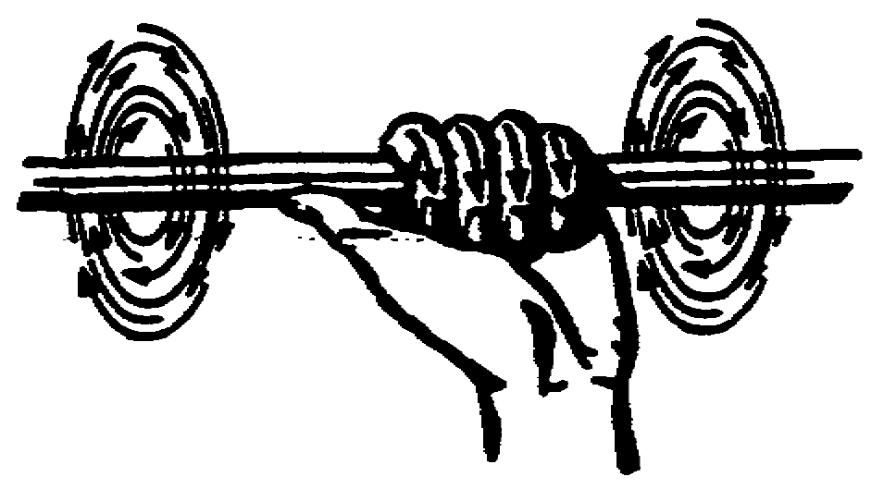

The conductor is grasped in the left hand, with the thumb pointing in the direction of current flow. The fingers curve in the direction of the lines of flux. To apply the left-hand rule to straight conductors, the technician must know the direction of current flow. The symbols used in determining the direction of current flow are illustrated below.

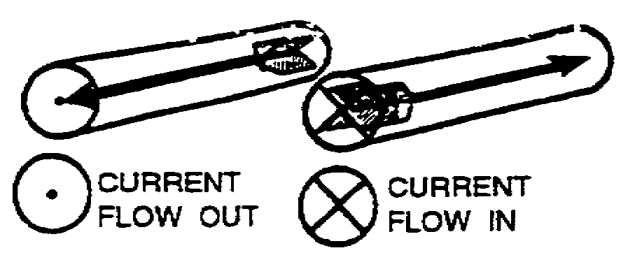

A circle represents the end of a conductor. A dot in the circle indicates an arrow tip showing current flowing out of the conductor. An X indicates current flowing into the conductor.

2-3 IT0349

1. (Continued)

These symbols, with their accompanying fields, are illustrated below.

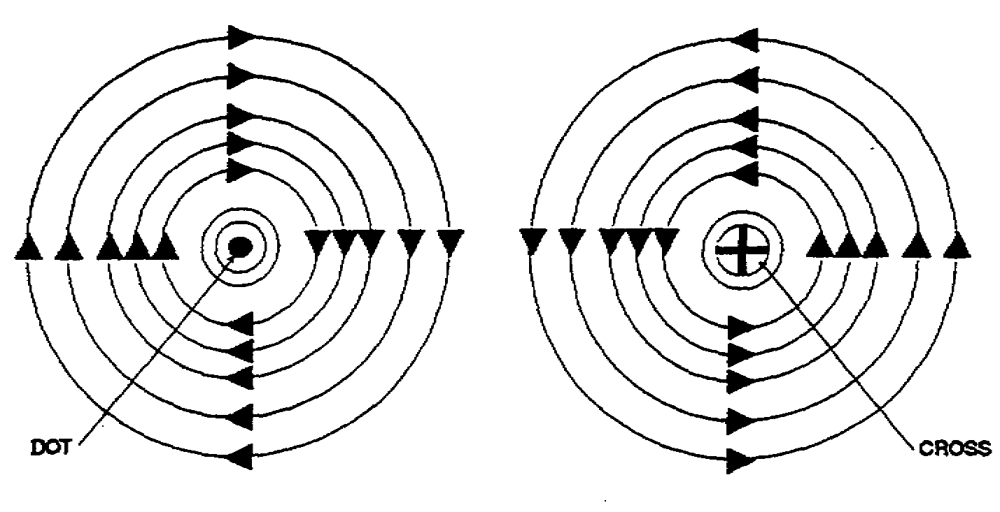

The left-hand rule for straight conductors states that when a conductor is grasped in the left hand with the thumb pointing in the direction of current flow, the fingers curve in the direction of the .

IT0349 2-4

lines of flux 2. The magnetic field around a straight conductor has little value. It has direction, but no north or south pole. It has force, but this force is relatively weak. The effects of the magnetic field around a current-carrying conductor are put to use by shaping the conductor into a coil. The field is concentrated in the core (or center) of the coil. This increases the strength of the field and establishes definite north and south magnetic poles.

The effects of shaping a conductor into a coil are illustrated below.

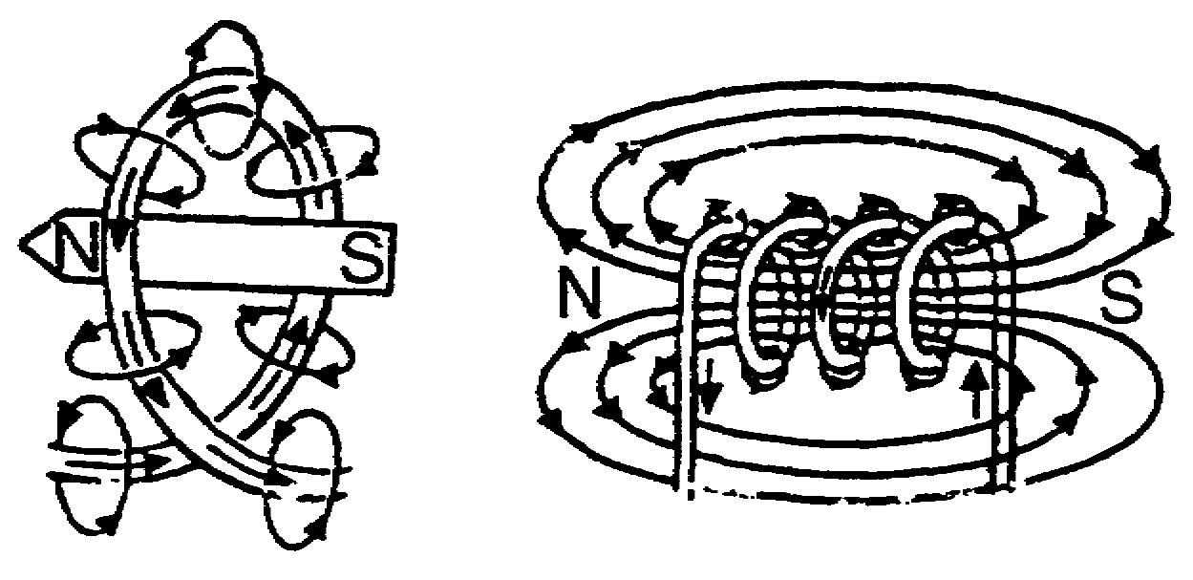

The field strength of a coil is greater than that of a straight conductor because, as the current flows through each parallel turn of the coil, the field around each turn of the coil aids (or adds to) the field of the next turn. An aiding field is illustrated on the following page.

2-5 IT0349

2. (Continued)
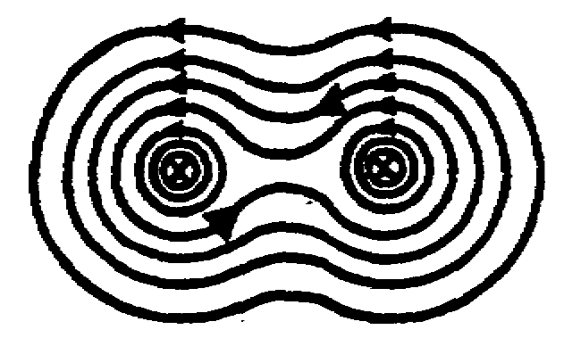

In parallel conductors with current flowing in opposite directions, opposing fields are set up and repulsion results. Opposing fields are illustrated below.

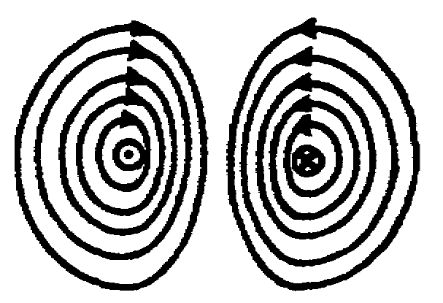

In addition to strengthening the magnetic field, the coil generates definite north and south magnetic poles. The LEFT-HAND RULE FOR COILS is used to determine the polarity of a coil. This rule is illustrated below.
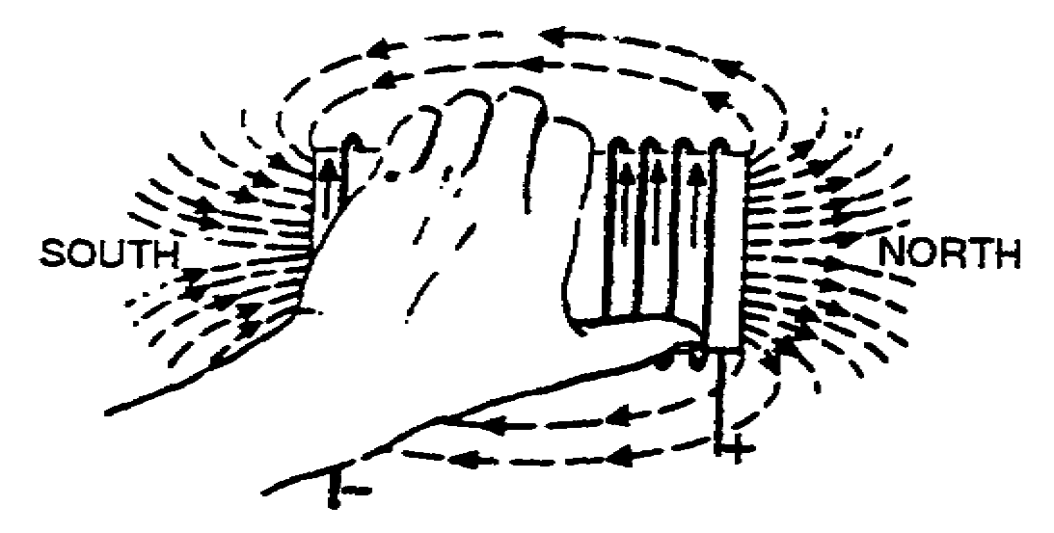

The left-hand rule for coils states that when a coil is grasped in the left hand with the fingers wrapped around the coil in the direction of current flow, the thumb points to the north pole.

IT0349 2-6

2. (Continued)

When a coil is grasped in the left hand with the fingers wrapped in the direction of current flow, the thumb points to the pole.

north 3. Indicate, with arrows, the direction of the magnetic lines of flux in the following diagram.

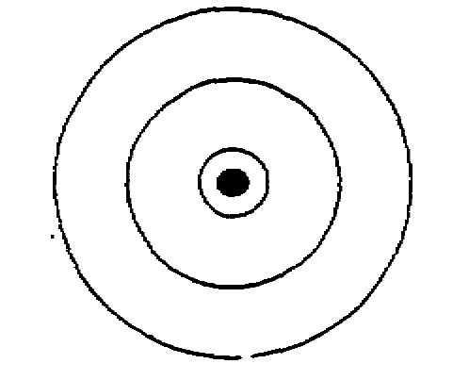

2-7 IT0349

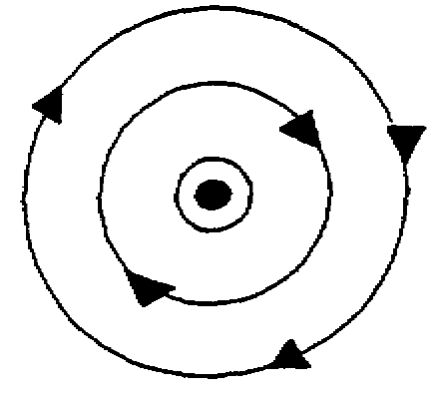
4. A coil with its concentrated magnetic lines of force becomes a basic ELECTROMAGNET. There are three main actor which affect the strength an electromagnet. The strength of the electromagnet varies directly with the number of turns of wire contained in the coil. The greater the number of turns, the stronger the magnetic field. The field strength also varies directly with the amount of current flow through the coil. Increased current flow results in an increase in the strength of the magnetic field. The third factor to be considered is the type of core material used. The ability of the core material (center of the coil) to conduct or concentrate lines of force, is known as the permeability of the core. Although various materials are used, the iron core is the most common and has a high permeability; thus, a stronger field results.

The three main factors which affect the strength of a electromagnet are the number of in the coil, the amount of through the coil, and the of core material used.

IT0349 2-8

turns 5. Label the north (N) and south (S) magnetic poles in the
current flow diagram flow below.
type
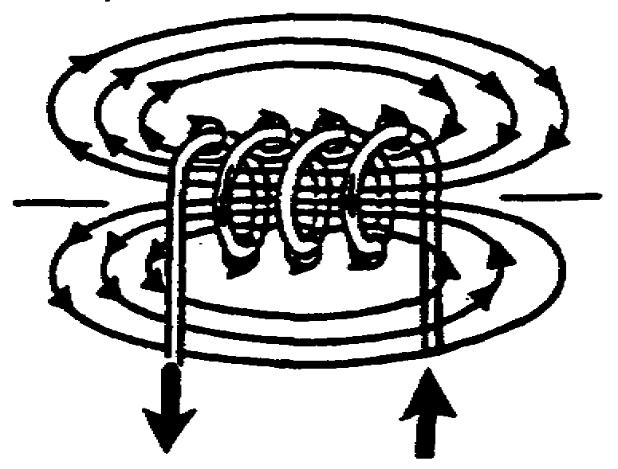

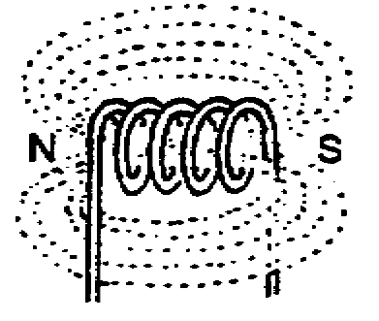
6. Indicate, with arrows, the direction of magnetic lines of flux in each of the following diagrams.
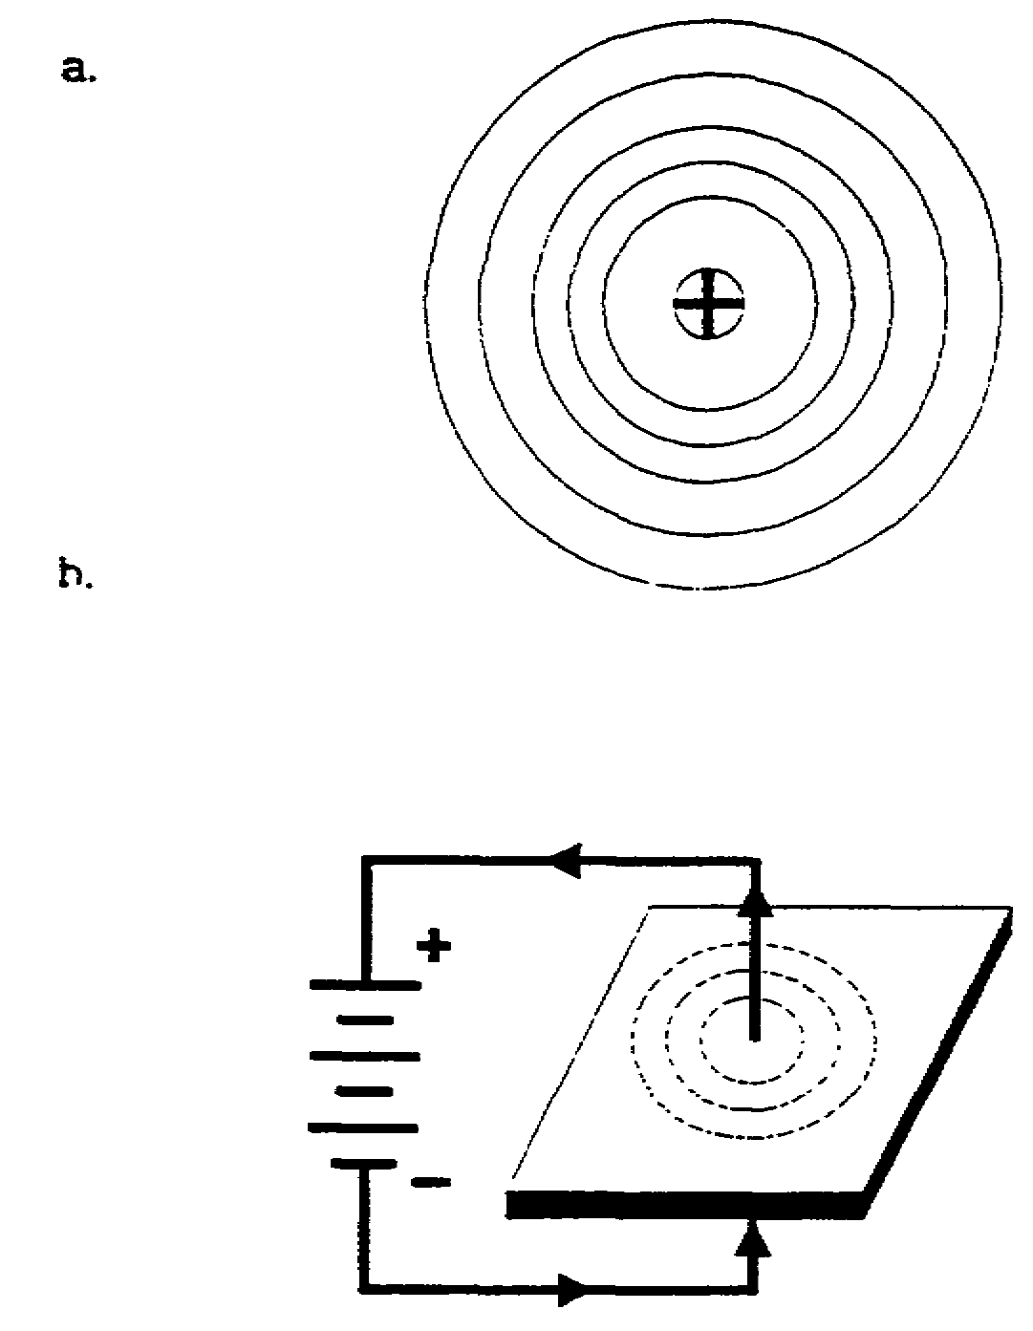

2-9 IT0349

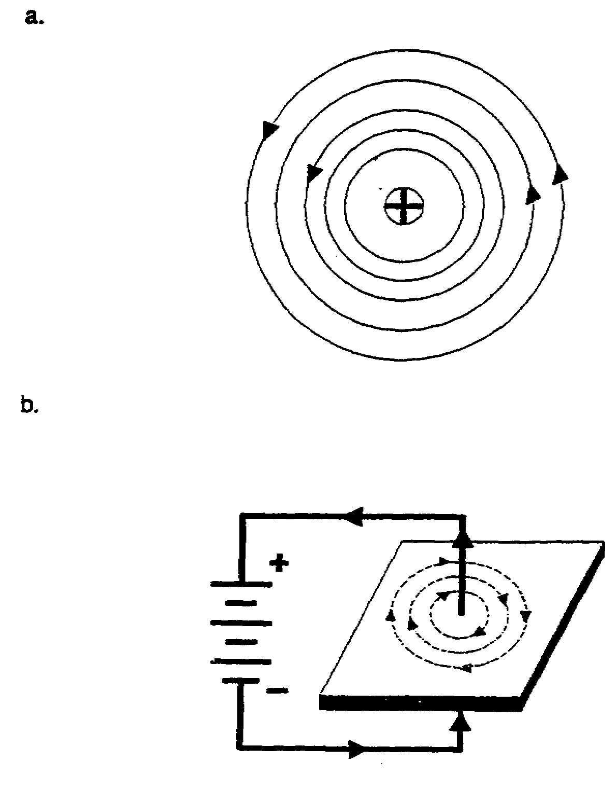

7. The field strength of an electromagnet is expressed in AMPERE-TURNS, abbreviated NI (N = the number of turns, and I = the current flow in amperes). To compute the ampere-turns rating of a coil, multiply the number of turns in the coil times the current flow through the coil. The field strengths (in ampere-turns) of two electromagnets can be compared if the electromagnets have the same type of core material.

IT0349 2-10

7. (Continued)

A comparison between two such electromagnets is illustrated below.

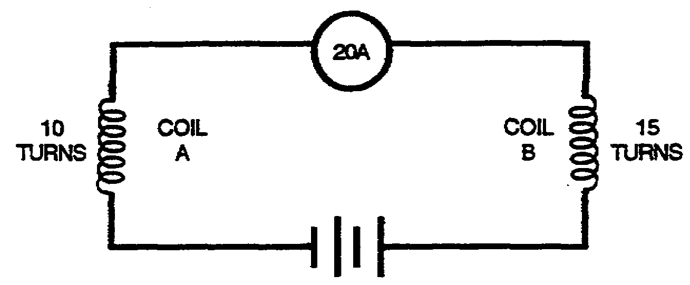

Using the formula ampere-turns = NI,

Coil A = 20 a x 10 turns = 200 ampere-turns

Coil B = 20 a x 15 turns = 300 ampere-turns

Thus, coil B has the stronger magnetic field. In the figure below, the stronger magnetic field is developed by coil .

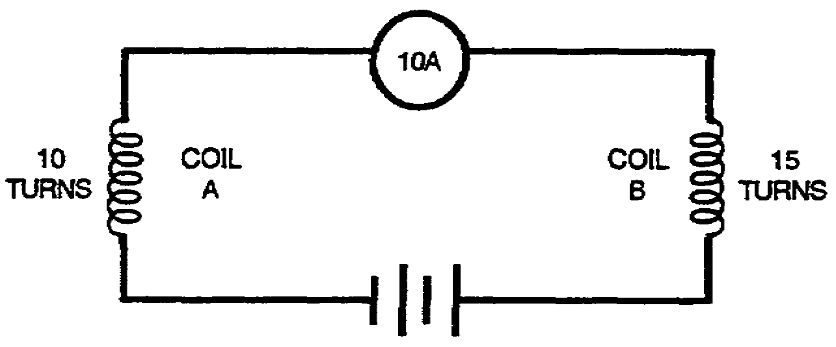

2-11 IT0349

B 8. Select the statement that correctly describes the factors determining the field strength of an electromagnet.

a. The length of the wire, the retentivity of the core material, and the amount of voltage.

b. The number of turns of wire, the resistance of the wire, and the type of core material.

c. The number of turns of wire, the amount of current flow, and the type of core material used.

d. The length of the wire, the amount of voltage, and the resistance of the core material.

c. 9. Label the north (N) and south (S) magnetic poles in each of the following diagrams.
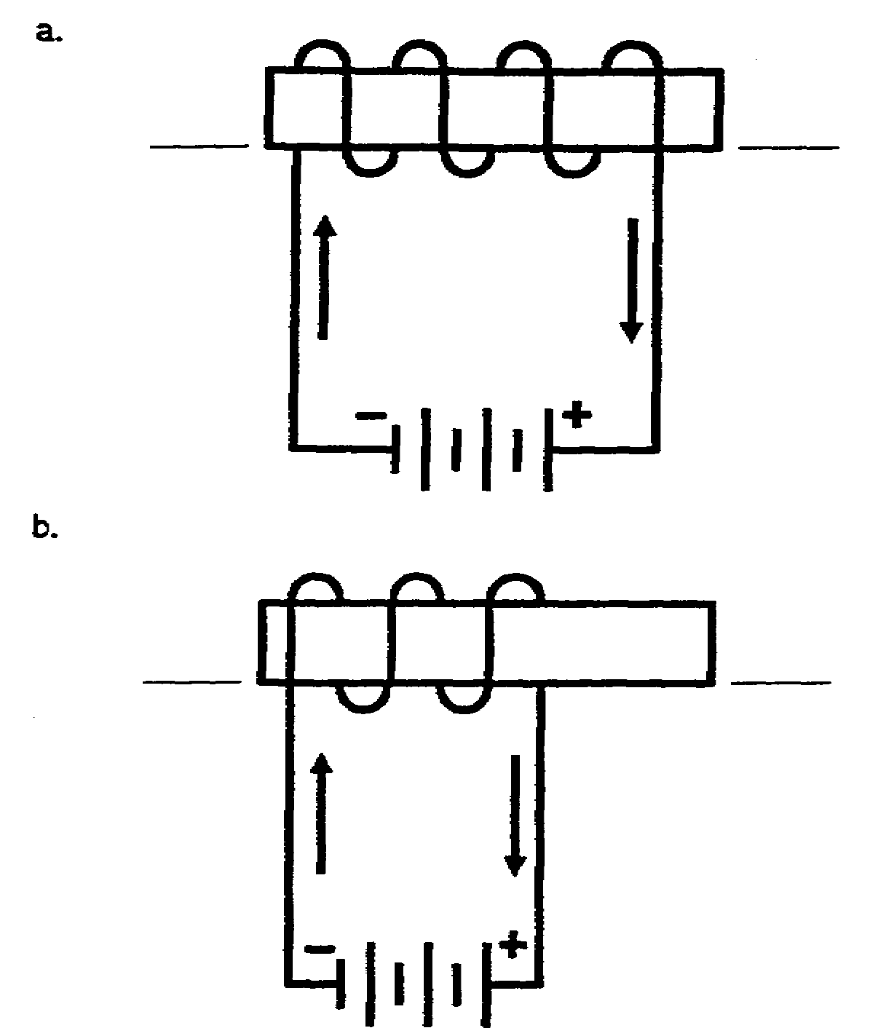

IT0349 2-12

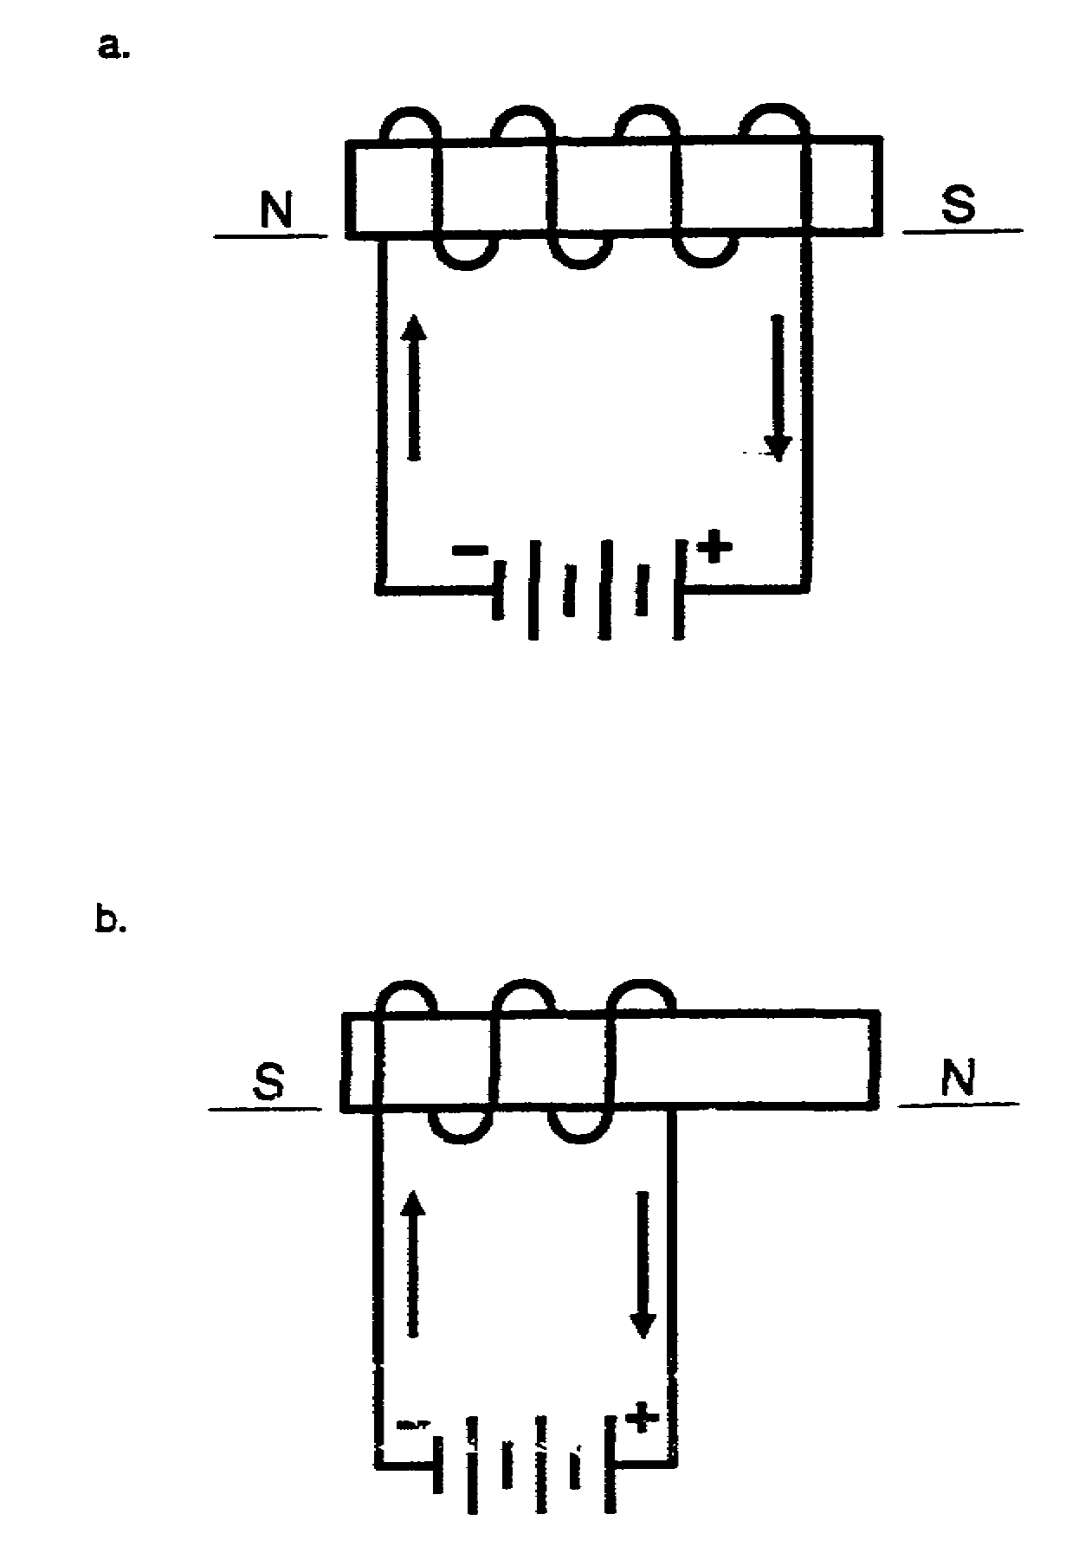

2-13 IT0349

10. There are three basic types of coils which are used in electrical circuit. The first type, the SOLENOID, is basically a coil of wire with an air core. A basic solenoid illustrated below.
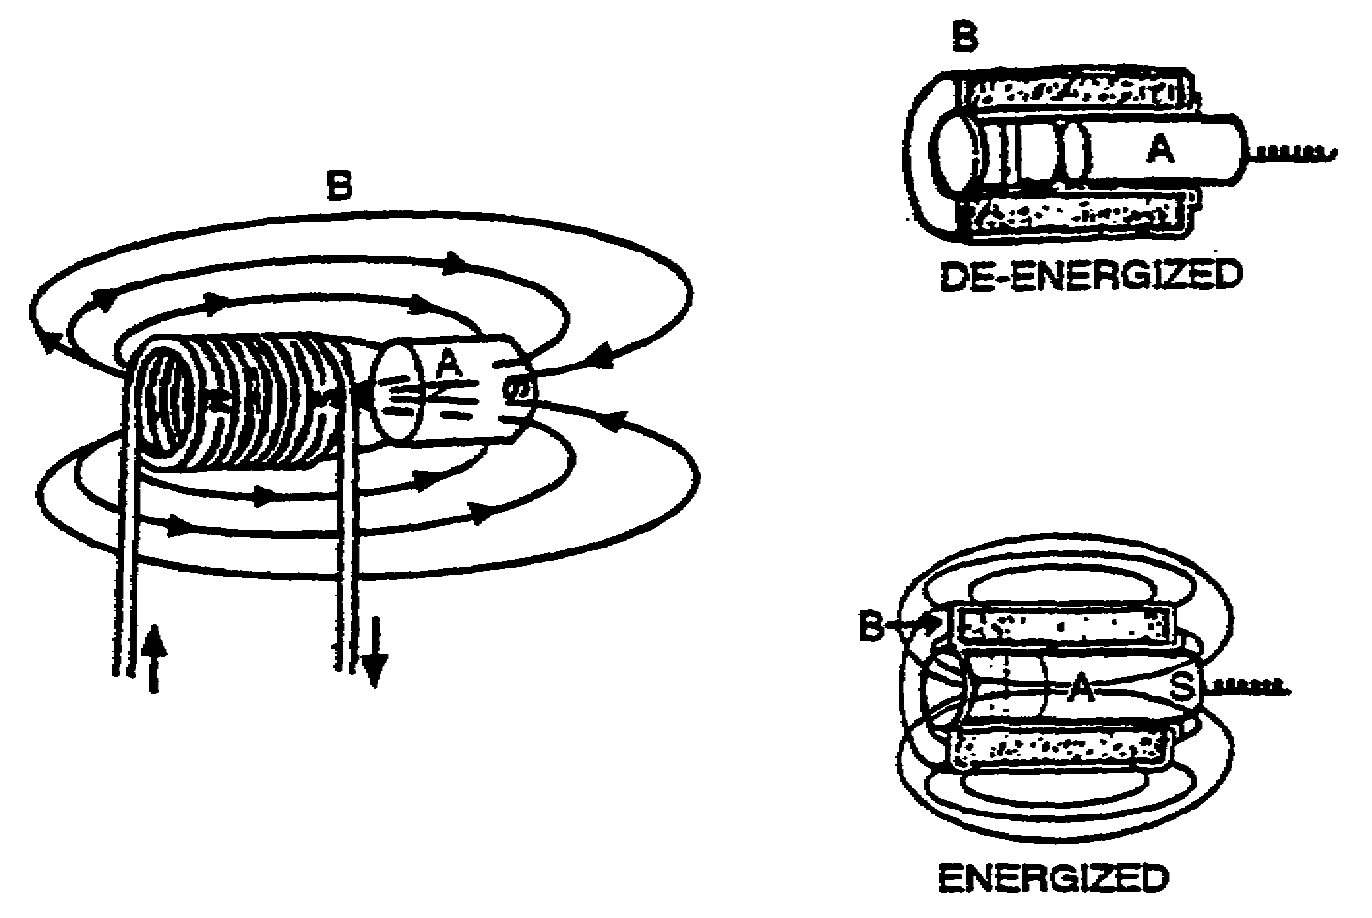

When an iron cylinder (A) is placed near one end of the energized coil (B), the flux lines are concentrated through the iron. The cylinder becomes a temporary magnet and is attracted by the solenoid. The iron cylinder is virtually sucked into the center the coil and replaces the air core. If a spring is attached to one end of the movable iron core, the core (plunger) is pulled out of the solenoid when the coil is de-energized. This creates a mechanical movement which can be put to work. The movable iron core centering itself in an energized coil is known as SOLENOID ACTION.

IT0349 2-14

10. (Continued)

The solenoid is basically a coil of wire with an
core.

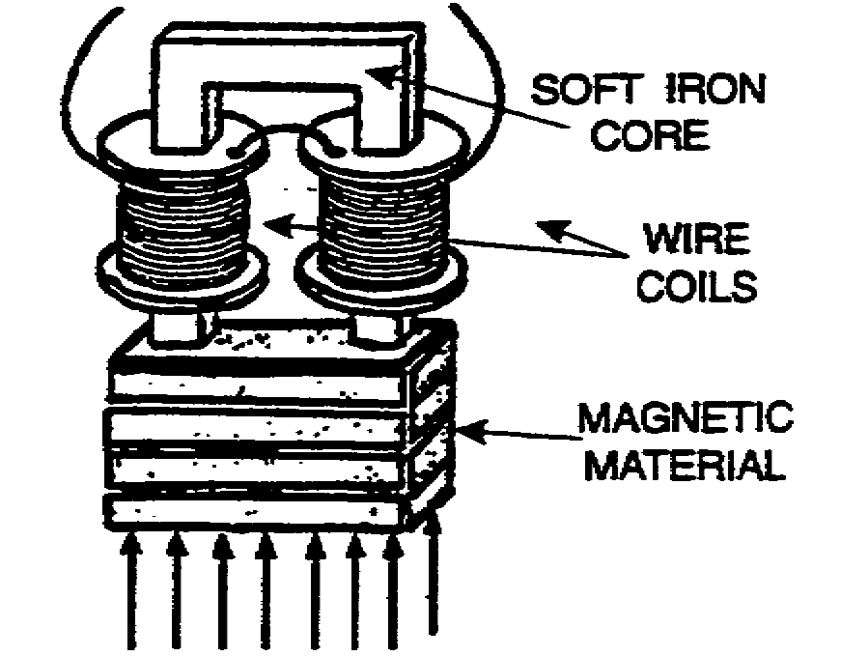
air 11. The second type of coil, the ELECTROMAGNET, is illustrated below.

The ELECTROMAGNET is composed of a coil of wire wound around a soft iron core which does not move. There are no moving parts-the coil is actually wound on the core material. Magnetic materials placed near the ELECTROMAGNET are attracted to the electromagnet when it is energized. The addition of the iron core gives the magnet a much stronger field than a magnet using an air core. The soft iron core is utilized because of its high permeability and low retentivity (ability to retain magnetism). When the coil is de-energized, the core must lose its magnetism quickly so that the magnetic materials will no longer be attracted to it.

2-15 IT0349

11. (Continued)

An electromagnet is composed of a coil of wire wound around a core.

soft iron 12. The third type of coil, the RELAY, is used extensively in electrical equipment. The relay is a REMOTE-CONTROL SWITCH. It uses either a solenoid or an electromagnet in its operation. The electromagnet or solenoid in a relay is used to open and lose the electrical contacts. The relay coil has a completely separate circuit from the circuit is controlling. A relay connected in series with an aircraft starter motor is illustrated below.

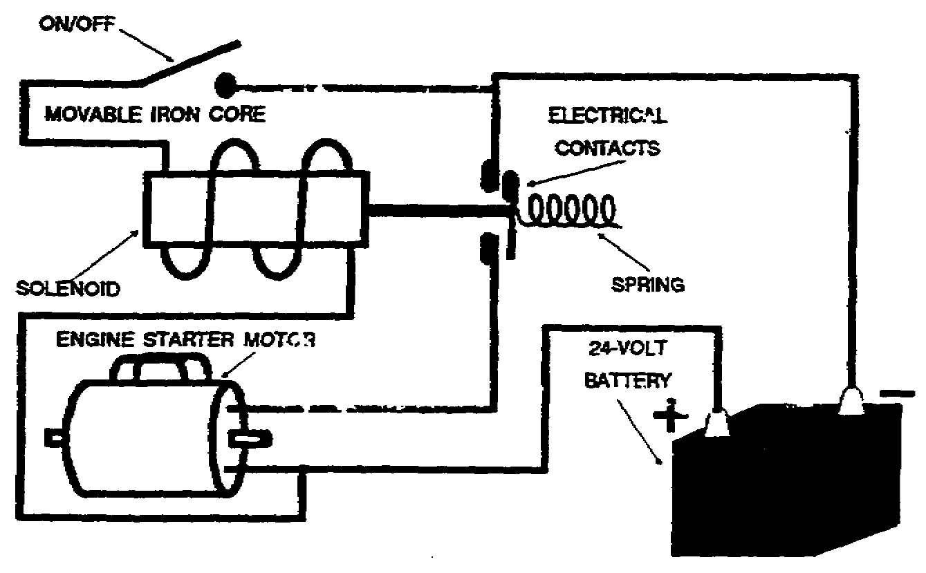

A separate circuit of small wire is routed through an on/off switch in the cockpit and then to the solenoid near the starting motor. When the cockpit switch is dosed, the solenoid energizes. The plunger, pulled into the coil, closes the contacts. This causes the starter motor to turn. When the solenoid relay is used, only a small guage wire is

IT0349 2-16

12. (Continued)

routed from the relay to the cockpit. The heavy current-carrying wire, which is kept as short as possible, remains near the engine. Smaller relays generally use electromagnets in their operation. A relay of this type is illustrated below.
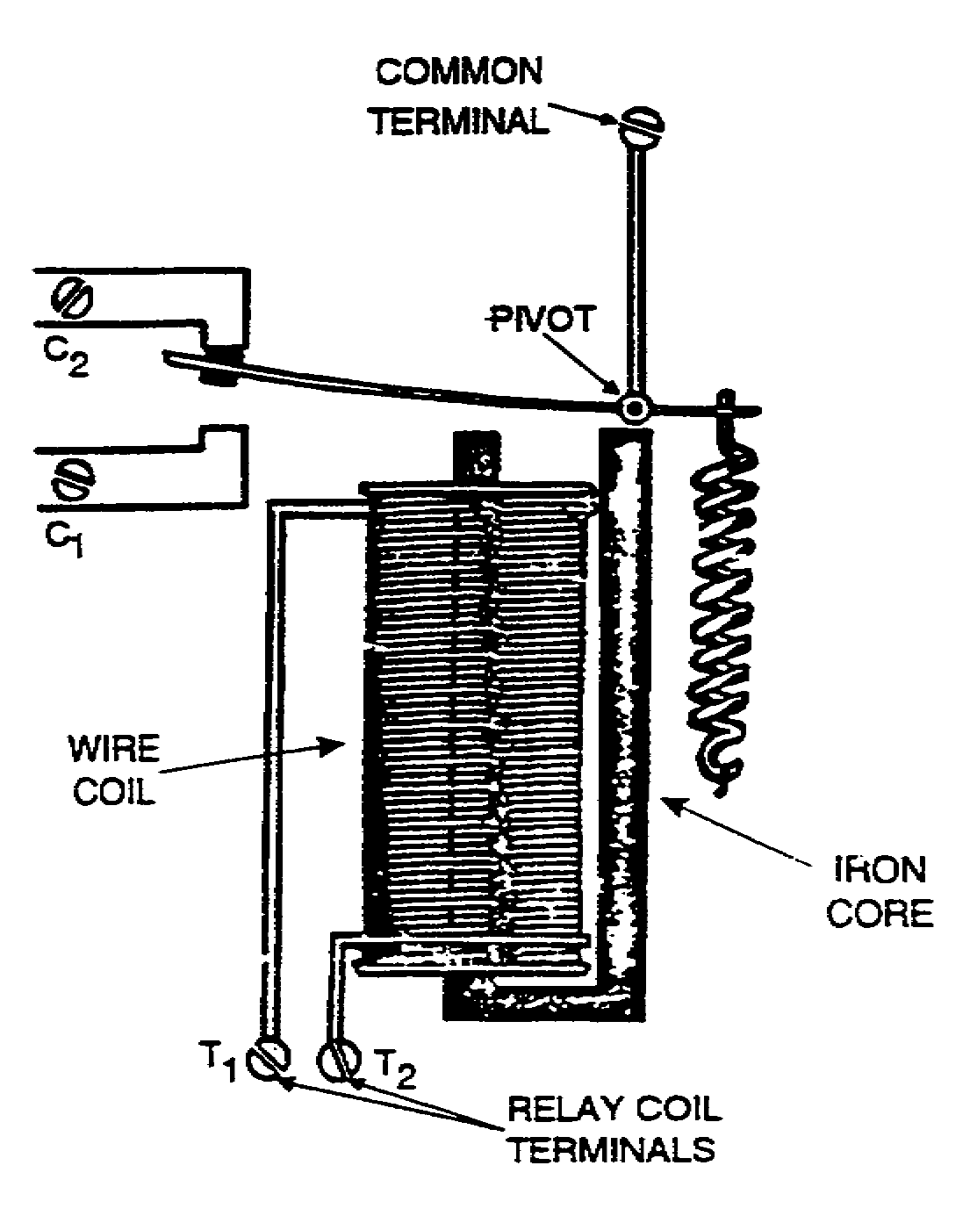

The common terminal, the C₁ terminal, and the C₂ terminal are in the controlled circuit. The relay coil has separate terminals (T₁ and T₂). All connections to this relay are the same as those to a solenoid, except for one difference: The relay has one more

2-17 IT0349

12. (Continued)

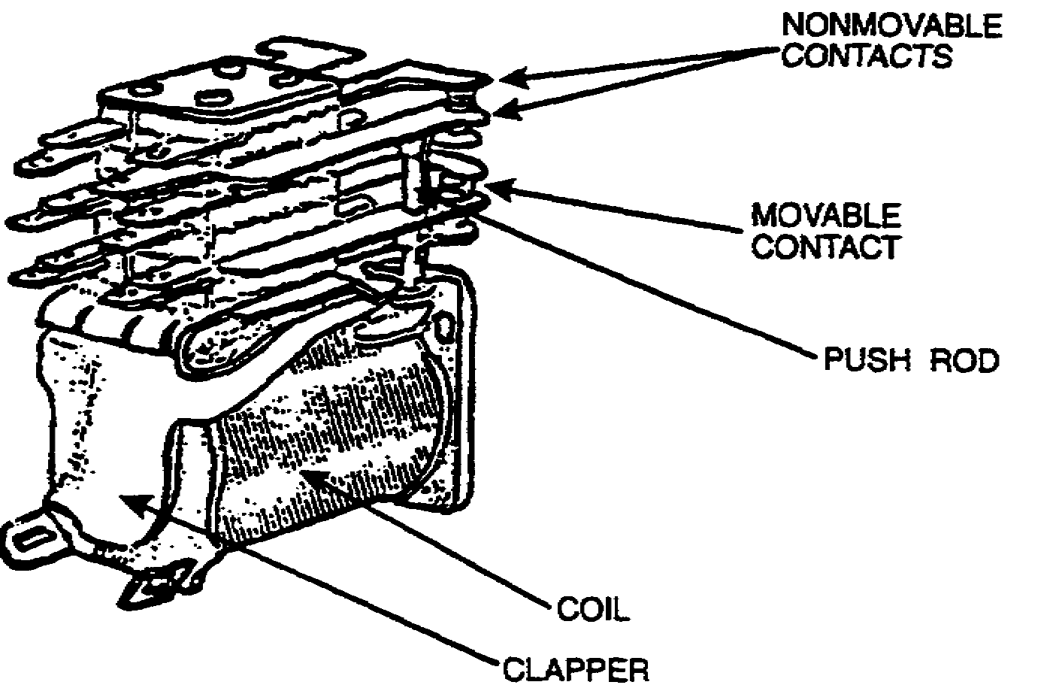
contact, which makes it more than just an on/off switch. When the relay is de-energized as shown, the circuit connected to C₂ is closed, while the C₁ circuit remains open. When the coil is energized, the movable contact (often called the armature) is attracted by the magnet, which causes the C₁ circuit to close. The C₂ circuit is now open.

Many multicontact relays are in common use. A multicontact relay is illustrated above. This relay has four sets of contacts. Each set of contacts operates just as it does in the previous illustration. When the relay is energized, four circuits are closed. When the relay is de-energized, the other four circuits are closed, and the first four circuits are opened.

Three types of coils commonly used in electrical equipment are the , the , and the .

IT0349 2-18

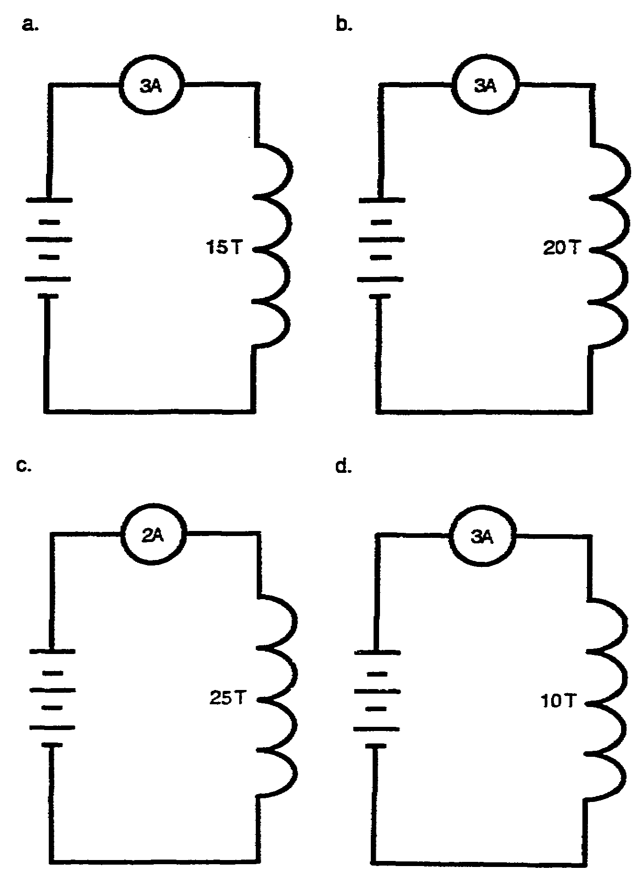
solenoid 13. From the group of coils shown below, select the coil
relay that has the strongest magnetic field.
electromagnet

2-19 IT0349

b. 14. List the three main factors that determine field strength of an electromagnet.

(1)

(2)

(3)

The number of 15. There are many devices which use electromagnets. A
turns of wire in the list of some of the more common devices is shown below.
coil.

The amount of a. Lifting electromagnets. g. Earphones.
current flow.
b. Magnetic circuit breaks. h. Loudspeakers.
The type of core
material used. c. Voltage regulators. i. Electric bells.

d. Motors. j. Buzzers.

e. Generators. k. Relays.

f. Meters.

Six devices that use electromagnets are:

(1) Lifting electromagnets.

(2) Voltage regulators.

(3)

(4)

(5)

IT0349 2-20

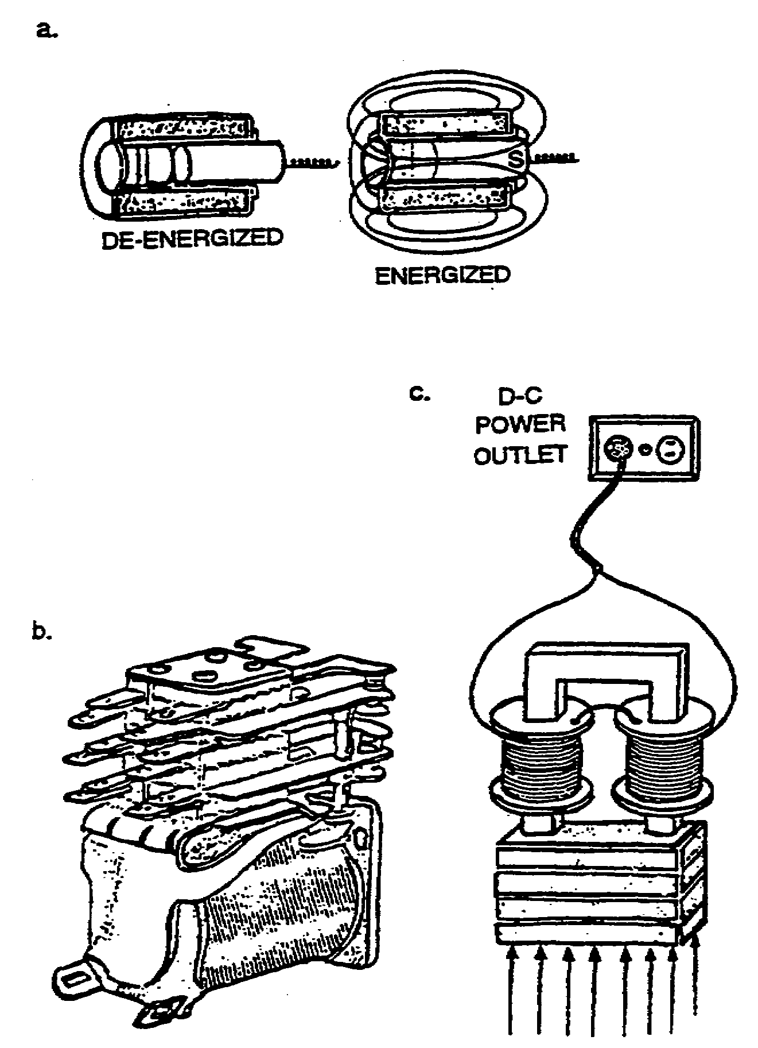
Magnetic 16. Label each of the following drawings as an
circuit electromagnet, a solenoid, or a relay.
breakers.

Motors.

Generators.

Meters.

Earphones.

Loudspeakers.

Electric bells.

Buzzers.

Relays.

(Any four.)

a. Solenoid

b. Relay

c. Electromagnet

2-21 IT0349

17. Select the coil below that has the strongest magnetic field.
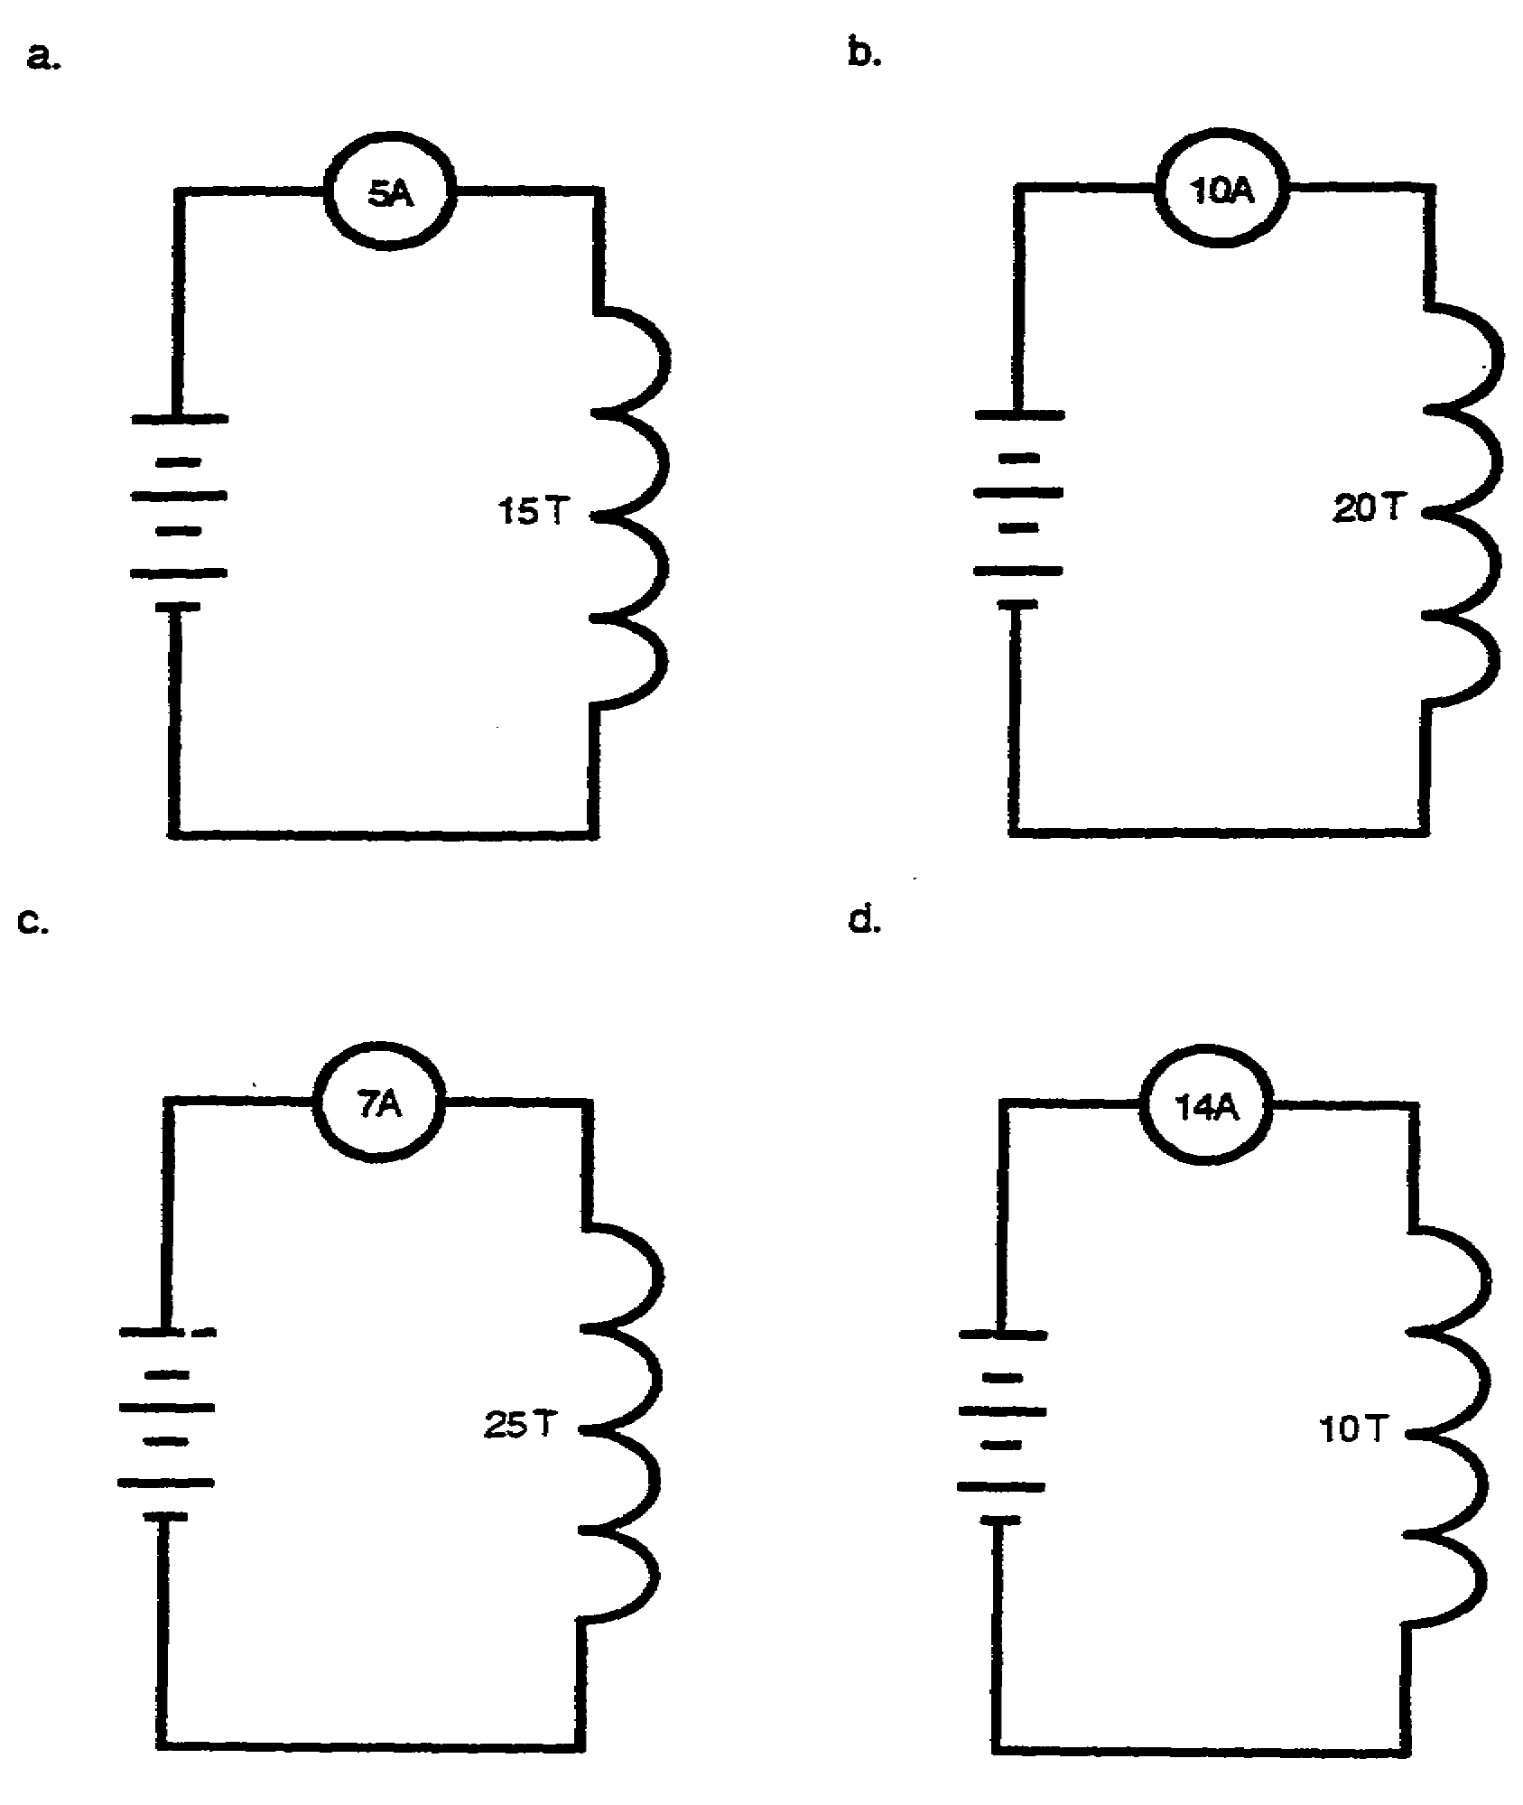

IT0349 2-22

b. 18. The relay has two main uses in electrical equipment. First, the relay is used to provide REMOTE CONTROL of electrical and electronic circuits, which enables the circuits to be energized from more than one station. This eliminates the need for running heavy power cables to control panels. Secondly, the relay is used for the REMOVAL OF SAFETY HAZARDS that threaten the operator. High-voltage circuits may be energized by a low-voltage relay.

The two man uses for a relay are the control of electrical circuits and the removal of .

remote 19. List six devices that use electromagnets.

safety (1)
hazards
(2)

(3)

(4)

(5)

(6)

2-23 IT0349

Lifting 20. Label each of the following drawings as an
electromagnets. electromagnet, a solenoid, or a relay.

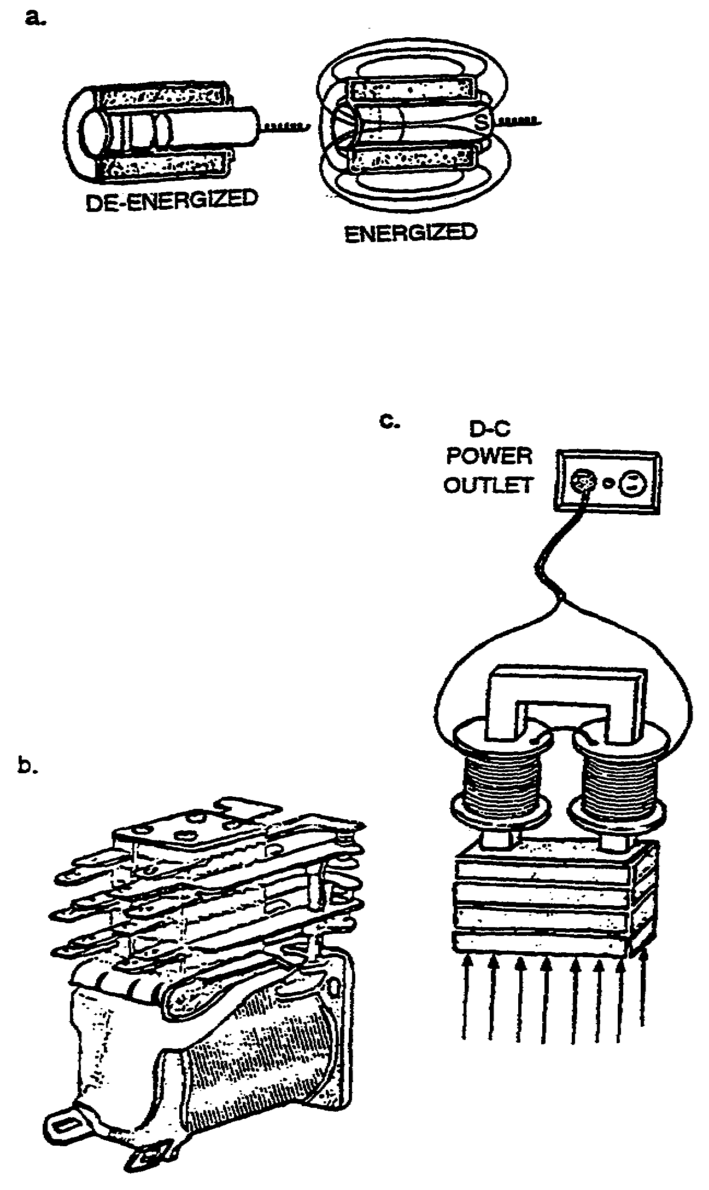
Magnetic
circuit breakers.

Voltage
regulators.

Motors.

Generators.

Meters.

Earphones.

Loudspeakers.

Electric bells.

buzzers.

Relays.

(Any six.)

IT0349 2-24

a. Solenoid 21. Select the correct statement.

b. Relay a. The two main uses of a relay are the remote control of electrical circuits and the removal of safety hazards.
c. Electromagnet
b. Relays are rarely used in electrical equipment.

c. The use of a relay offer no advantage over the use of an ordinary electrical switch.

d. Relay often present safety hazards rather than prevent them.

a. 22. List four devices that use electromagnets.

(1)

(2)

(3)

(4)

2-25 IT0349

Lifting 23. List the two main uses of a relay.
electromagnet.
(1)
Magnetic
circuit breaker. (2)

Voltage
regulators.

Motors.

Generators.

Meters.

Earphones.

Loudspeakers.

Electric bells.

Buzzers.

Relays.

(Any four.)

The remote control You have completed this program. Review the objectives
of electrical on page i & ii, if you do not completely understand an
circuits. objective, turn to the frame/s indicated by the
number/s in parentheses.

The removal of
safety hazards. REFERENCES:

1. Basic Electricity. NAVPERS 10086-A. Washington, D.C.: Government Printing Office, 1960. Chapter 1, pages 7-14, and chapter 7, page 120-129, 200-210.

2. Grob, Bernard. d Basic Electronics. New York: McGraw-Hill Book Company, Inc., 1965. Chapter 11, pages 198-210, and chapter 12, pages 221-229.

3. Slurzberg, Morris, and William Osterheld. Essentials of Electricity-Electronics. Third Edition. New York: McGraw-Hill Book Company, Inc. Chapter 5, pages 143-160.

IT0349 2-26

EXAMINATION

Materials needed to take this examination:

Subcourse booklet; a number 2 lead pencil; and ACCP Examination Response Sheet.

Instructions:

There is only one correct answer for each item. Mark the correct answer for each item, then transfer your answer to the ACCP Examination Response Sheet, completely blacking out the lettered oval which corresponds to your selection (A B, C, or D). Use a number 2 lead pencil to mark your responses. Mail your response sheet in the preaddressed envelope you received with this subcourse.

In each of the following items, select the one answer that best completes the statement or answers the question.

1. Decide if either or both of the following statements are true. Then pick the best answer below.

STATEMENT ONE: The molecules of an unmagnetized iron bar possess both North and South poles.

STATEMENT TWO: In a magnet, most of its molecules are lined up so that their South poles point in the same direction.

A. Only STATEMENT ONE is correct.

B. Only STATEMENT TWO is correct.

C. Both STATEMENTS are correct.

D. Neither STATEMENT is correct.

E-1 IT0349

2. Select the statement which correctly describes the flux field of a magnet.

A. The lines of force extend from the north pole to the south pole externally, and back through the magnet to the north pole. These lines of force constitute the force field which is called the magnetic flux field.

B. The lines of force, which make up the flux field, extend from the north pole to the south pole through the magnet, and back to the north pole. The density of these lines is limited by the physical size of the magnet.

C. The lines of force (magnetic field) which surround a magnet make up the flux field. These lines have direction and extend from the north pole through the magnet to the south pole, and externally back the north pole.

D. The lines of force which extend from the north pole externally to the south pole are known as the flux field. The internal lines of force from the south pole back to the north pole are called the magnetic field.

3. The ease with which the lines of force travel through the magnet itself depends on which property of the magnet?

A. RELUCTANCE

B. RETENTIVITY

C. PERMEABILITY

D. SATURATION point

4. RELUCTANCE may be defined as the

A. ease of passage of flux lines.

B. opposition offered by a magnetic substance to magnetic flux.

C. nature of a material to lose magnetism after magnetization has ceased.

D. restriction as to the maximum number of lines of force a material can contain.

IT0349 E-2

5. The condition existing in a magnetic material when the flux density is the maximum that can be obtained by increasing the magnetomotive force is called

A. RELUCTANCE.

B. SATURATION.

C. RETENTIVITY.

D. PERMEABILITY.

6. Which is the best definition of RETENTIVITY?

A. The limit of magnetic strength.

B. The ease of passage of flux lines.

C. The amount of magnetism remaining after the magnetomotive force is removed.

D. A measure of the ability of an iron alloy material to retain its magnetism.

7. Residual magnetism should be expected to be greater in

A. an electromagnet.

B. a temporary magnet.

C. a piece of magnetized soft iron.

D. a piece of magnetized steel or alnico.

8. The three general types of magnets are

A. natural, temporary, and permanent.

B. natural, artificial, and permanent.

C. natural, artificial, and electromagnet.

D. temporary, permanent, and electromagnet.

E-3 IT0349

9. When an electric current flows through a straight conductor, magnetic lines of force are generated at right angles to the conductor. These lines of force

A. have both north and south poles.

B. are directional.

C. are not affected by the direction of current flow.

D. All of the above are correct.

10. When applying the left-hand rule,

A. the direction of current flow must first be determined when using straight conductors.

B. the fingers curve in the direction of the lines of flux.

C. the thumb must point in the direction of current flow.

D. all of the above are correct.

11. Select the illustration, using the left-hand rule, which depicts the correct relationship between direction of current flow and the direction of lines of force. When correctly identified, the long arrow will correspond to direction of current flow.
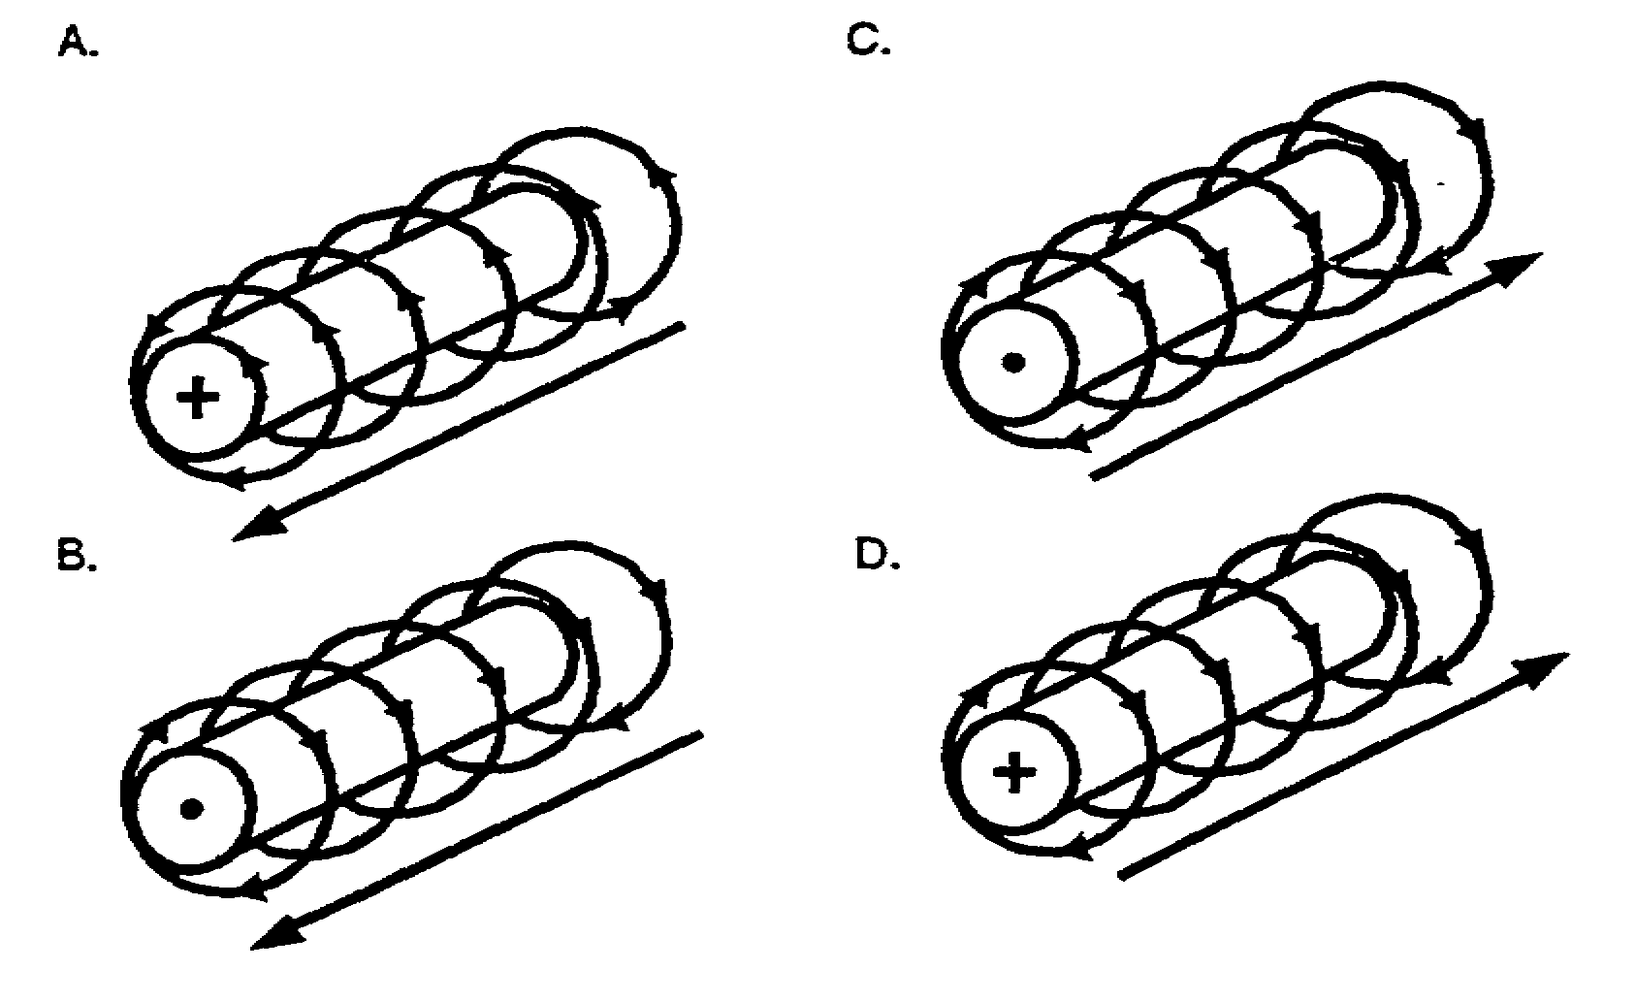

IT0349 E-4

12. What are the three main factors which affect the strength of an electromagnet?

A. The type of wire contained in the coil, the amount of current flow, and the size of core material.

B. The number of turns of wire contained in the coil the direction of current flow, and the type of care material.

C. The number of turns of wire contained in the coil, the amount of current low, and the type of core material.

D. The number of turns of wire contained in the coil, the amount of current flow, and the size of the core material.

13. Select the diagram which has the north (N) and south (S) pole labeled correctly.
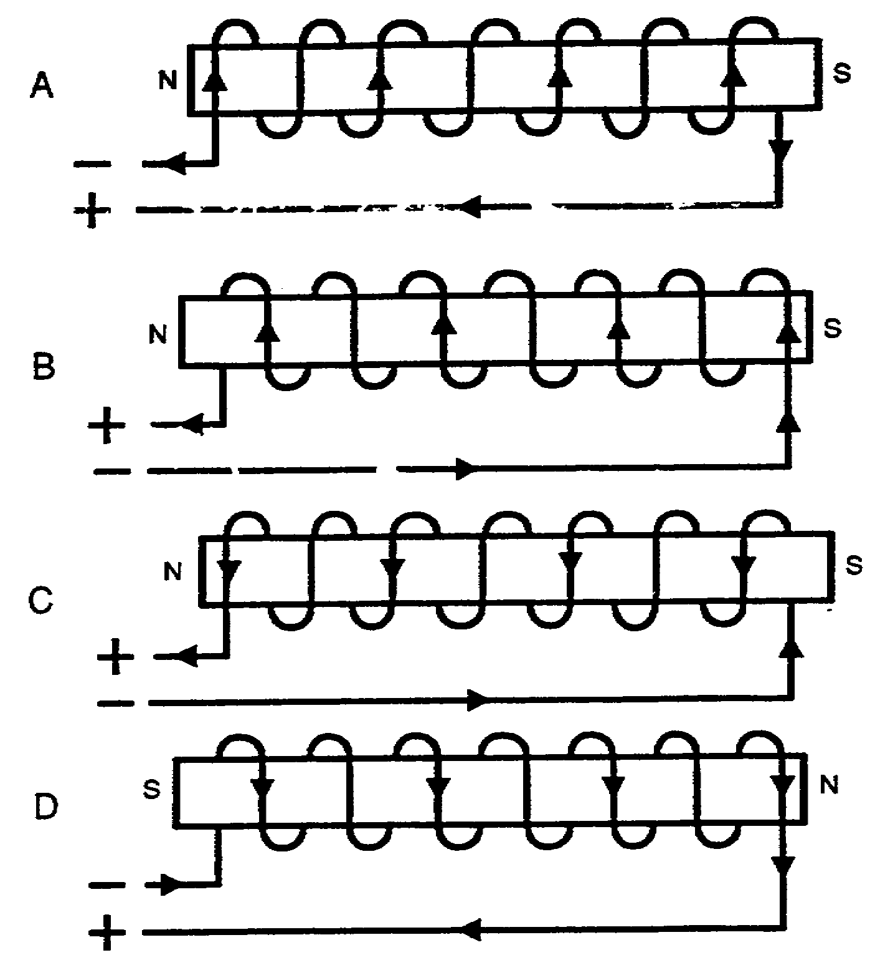

E-5 IT0349

Question 14 will refer to the following diagram of a horseshoe magnet.
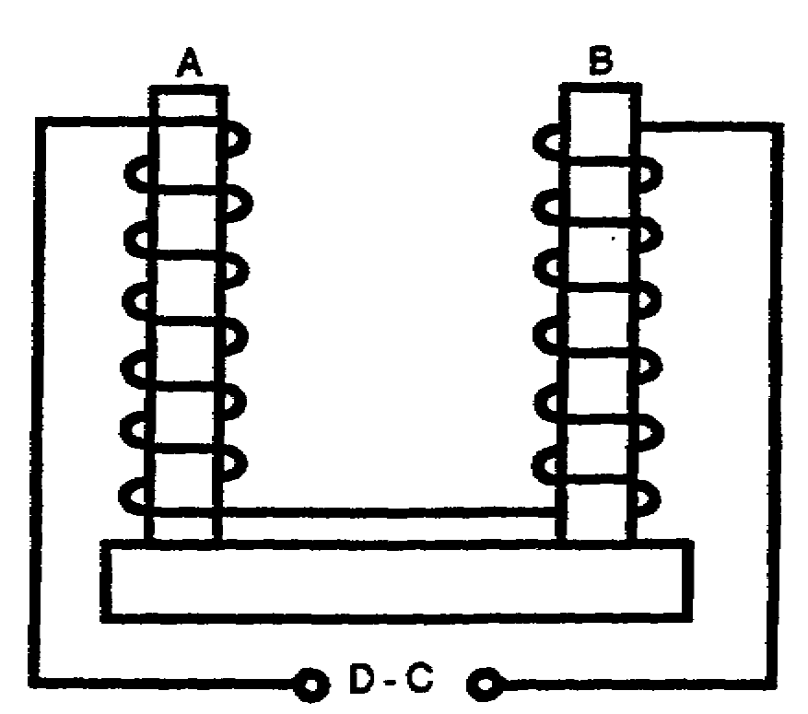

14. Select the statement which is applicable to the horseshoe magnet as wired.

A. Poles a and b will exhibit south and north poles respectively when current flows in a counterclockwise direction.

B. Poles a and b will exhibit south and north poles respectively when current flows in a clockwise direction.

C. Poles a and b will exhibit north and south poles respectively when current flow in a clockwise direction.

D. Current flow in either direction cannot create opposite polarity between a and b because each pole has its coil wound in the same direction.

15. Select one of the three basic types of coils which would be employed to convert electrical energy to the mechanical energy necessary to open/close a valve.

A. Solenoid

B. Electromagnet

C. Relay

D. Any of the above would serve this function.

IT0349 E-6

16. Select one of the three basic types of coils which would be configured as a switch and wired into a circuit for remote operation.

A. Solenoid

B. Electromagnet

C. Relay

D. None of the above would serve this function.

E-7 IT0349

